RESOLUTION NO.__________

RE: CERTIFICATE OF APPROPRIATENESS UNDER THE
PROVISIONS OF THE ACT OF THE PENNSYLVANIA
LEGISLATURE 1961, JUNE 13, P.L. 282 (53
SECTION 8004) AND BETHLEHEM ORDINANCE NO.
3952 AS AMENDED.

WHEREAS, it is proposed to replace the existing sign with a new sign for the new business at 516 Main St.

NOW, THEREFORE, BE IT RESOLVED by the Council of the City of Bethlehem that a Certificate of Appropriateness is hereby granted for the proposal.

Sponsored by: (s)

(s)

ADOPTED BY COUNCIL THIS DAY OF

(s)
President of Council

ATTEST:

(s)
City Clerk

HISTORICAL & ARCHITECTURAL REVIEW BOARD

The applicant is proposing to replace the existing sign with a new sign for the new business at 516 Main St.
APPLICATION #2:

CTI-PA Investments, LLC
2121 Rosecrans Ave. #1300
El Segundo, CA 90245

OWNER:

__________________________________________________________________________

The Board upon motion by Nancy Shelly and seconded by Marsha Fritz adopted the proposal that City Council issue a Certificate of Appropriateness for the following:

- The existing metal bracket will be reused and the existing blade sign will be removed.

- The new sign will be approximately 36” wide x 28” high.

- The background color to match the blue color on the business card submitted.

- Pin stripe to be added approx.. ½” x to ¾” in from perimeters and eliminate the border.

5. The motion was unanimously approved.
__________________________________________________________________________

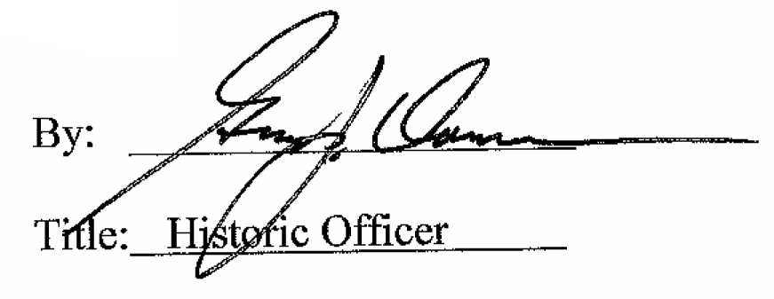

Date of Meeting: September 7, 2016

